CRUD Operations
CRUD stands for Create, Read, Update, and Delete. These operations are used to manage data in a database.
Create Operation
The INSERT statement is used to add a new product to the product table.
INSERT INTO product(product_name, price, category_id)
VALUES('Night Cream', 1100, 1);
Explanation:
A new product named Night Cream is added with a price of ₹1100 and category ID 1 (Skincare).
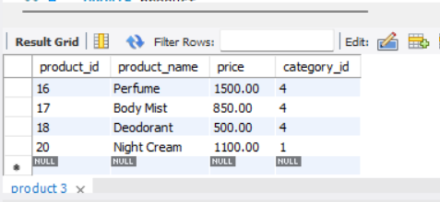

Read Operation
The SELECT statement is used to retrieve data from the table.
SELECT * FROM product
WHERE product_id = 18;
Explanation:
This query displays the details of the product whose product_id is 18.
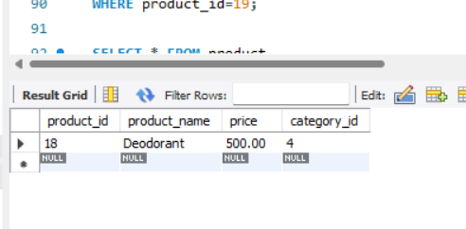

Update Operation
The UPDATE statement is used to modify existing data.
UPDATE product
SET price = 1300
WHERE product_id = 18;
Explanation:
The price of the product with product_id = 18 is changed from ₹1100 to ₹1300.
To verify the updated data:
SELECT * FROM product
WHERE product_id = 18;
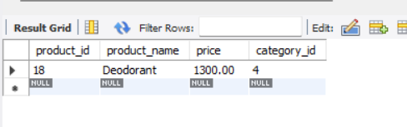

Delete Operation
The DELETE statement is used to remove a record from the table.
DELETE FROM product
WHERE product_id = 19;
Explanation:
This query deletes the product with product_id = 19 from the product table.
To verify the remaining products:
SELECT * FROM product;
